# News story

|  |  |  |
| --- | --- | --- |
| **Name of DocSet** | **Electronic card transactions: August 2020** | |
| Release date | 10 September 2020 | Job no: 13379 |
| Topics in your story we could use for an image on the website: | | |

## Is there a related release?

|  |  |
| --- | --- |
| **Release title** |  |
| Release date |  |

## Hospitality struggles under higher COVID-19 alert level restrictions

Card spending on hospitality fell in August 2020, Stats NZ said today.

“Spending on both eating out and accommodation away from home fell in August due to 19 days of COVID-19 alert level 3 restrictions in Auckland and alert level 2 restrictions for the rest of New Zealand,” retail statistics manager Kathy Hicks said.

In actual terms, spending on food and beverage services, which includes businesses such as cafes, restaurants, takeaway food, and bars, fell 13 percent ($115 million) compared with August 2019. This follows an 11 percent ($92 million) increase in July 2020 compared with July 2019.

“Under level 3 in Auckland, cafes and restaurants could only sell meals through contactless takeaways or home deliveries.

“Under level 2, customers could dine in, though social distancing measures restricted the number of seats available, so most were still operating below normal levels,” Ms Hicks said.

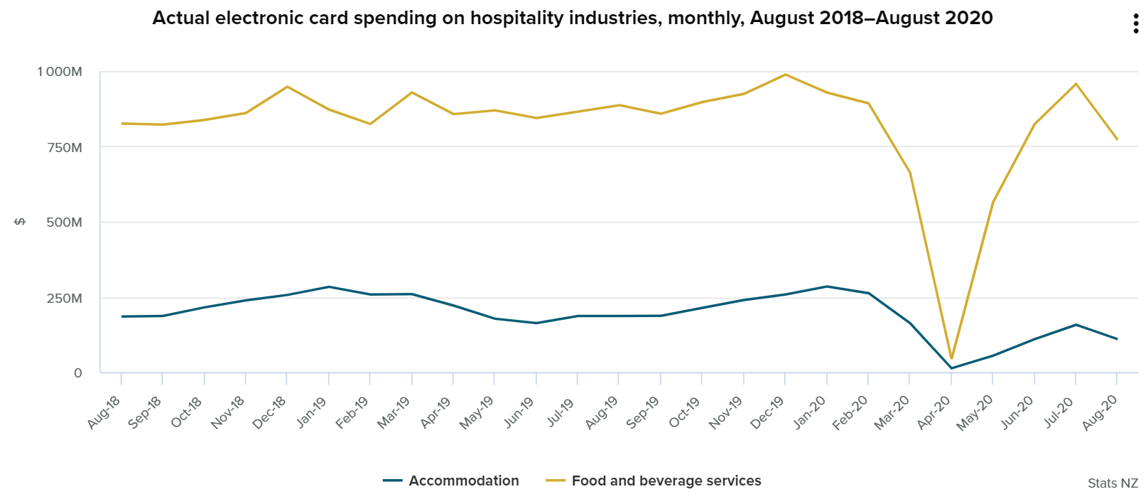

Spending on businesses such as motels, hotels, and other accommodation fell 41 percent ($77 million) compared with August 2019. This follows a 16 percent ($30 million) fall in July 2020 compared with July 2019.

## Card spending on travel and tourism struggles to lift

“Spending on travel and tourism services also fell in August 2020 compared with the July month, impacted by one-third of the team of 5 million staying home under level 3 restrictions,” Ms Hicks said.

Actual card spending on travel agency and tour arrangement services fell 97 percent ($144 million) compared with August 2019.

“This month’s fall followed a small recovery in domestic travel and tourism in July, when New Zealand was under a full month of alert level 1 with restrictions lifted except border controls.”

Actual card spending on travel agency and tour arrangement services fell 68 percent ($8.4 million) compared with the July 2020 month.

“Travel and tourism services continued to be affected by border closures to international visitors and by the lack of New Zealanders booking overseas travel,” Ms Hicks said.

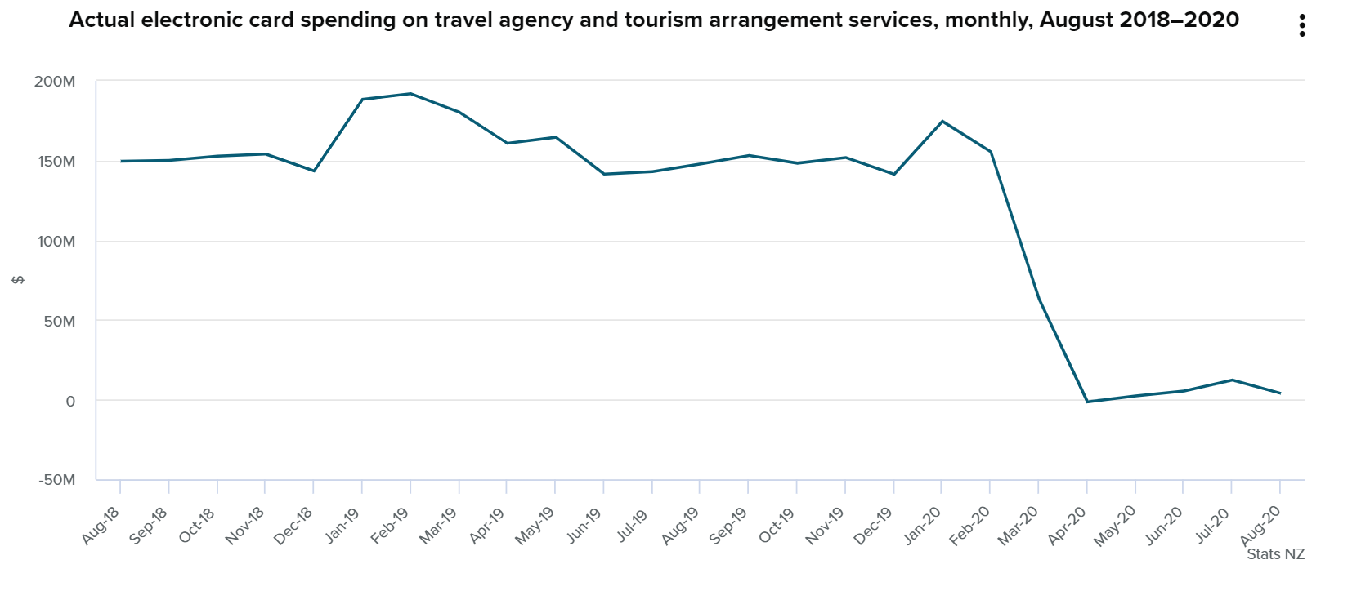

## Media enquiries

## Kathy Hicks

## 03 964 8351